Template - Annie
Soul School Website Blueprint (5 Pages)
This simplified version to build:
5 pages total
Home
What is Soul School
Calendar
Enter
Protected page

1. Home (Public)
Purpose: Orientation + threshold + calendar

Sections

SOUL SCHOOL

A new educational playground for the future human.

[Enter Soul School] - links to password (WEAREFREE)

[What is Soul School?] - links to public page

[Member Login] - private personal password

Calendar
Upcoming Gatherings
• Soul School Bus Popups— Boulder
• Soul School Office Hours (Zoom)
• Retreat Orientation
(Google Calendar API connection)

2. What is Soul School? (Public)
How Access Works
The best way to understand Soul School is to show up.
In a world engineered for distraction, showing up is RADICAL. Above all, we show up, for ourselves, each other, and our planet.
Attend a gathering.
Meet the community.
Look for the Soul School bus.
Participants at events may receive the access code.
CALENDAR HERE

For those outside our region
Online gatherings are announced through the calendar. You can also email annie@postinternetproject.org with “Soul School” in the subject line and we’ll add you to our mailing list. The emails are very short and only include the date and time of upcoming online events. We respect your sovereignty, which means we respect your inbox too.
STUFF BELOW HERE ON CAROSEL(C) BY SECTION??

The Era We’re Entering (C1)
We are living in an era of profound disorientation.
The internet has connected us to everything while simultaneously disconnecting us from ourselves. Information is infinite and meaning is scarce. Artificial intelligence now surpasses human analytic capacity while human emotional maturity, perceptual clarity, and inner coherence remain underdeveloped.
The result is a widespread inability to sense what is real, meaningful, or aligned.

What’s Broken in Higher Education (C2)
Most systems of traditional higher education were designed for an industrial world.
They train the analytic intellect while neglecting the inner world — the place where perception, intuition, discernment, and emotional coherence actually live.
As a result, many people enter adulthood without the ability to:
- steward their attention
- regulate their nervous systems
- interpret reality with discernment
- trust their intuition
- build lives aligned with their values

Soul School Response (C3)
Soul School is a new model of higher education designed for the era we are entering.
We cultivate the capacities machines cannot replicate and institutions rarely teach: discernment, intuition, embodied intelligence, inscendence, creative courage, and the ability to generate coherence within oneself and in community.
We are here to train sovereign humans — people who can perceive clearly, stand in their own authority, and participate in shaping the future with clarity, courage, and joy.

The Paradigm Shift (C4)
A growing body of research across neuroscience, physics, and consciousness studies points toward a profound shift in how we understand reality: consciousness is foundational.
At a time when artificial intelligence is advancing rapidly, the leading edge of human evolution is the expansion of consciousness itself — yet most old-world institutions behave as if consciousness is not even a legitimate subject of study.
Soul School exists to train the capacities of expanded consciousness so that the future human can begin to take shape.

Core Pillars (C5)
(visual list only)
- Nervous System Alchemy
- Sovereign Discernment
- Inscendence
- Authentic Creative Expression
- Field Intelligence

Is Soul School for me? (C6?? Or maybe text below carosel?)
Soul School is for people who:
- have a sense that something about the current world (and the current educational system) isn’t quite right
- want something deeper than conventional higher education tends to offer
- are curious about consciousness and open to the possibility that it is foundational to reality
- would rather help build the future than spend their lives critiquing the present
- understand that real Jedi-style mastery requires practice, discipline, and humility
Soul School is designed for people who are ready to step into the future from the inner authority of the Soul.

Advisory Council
Headshots and bios section
Marjorie Woollacott
Science Advisor
Marjorie Woollacott, PhD, is a neuroscientist and Professor Emerita at the University of Oregon. Her research explores the relationship between neuroscience, consciousness, and human potential. She is the author of Infinite Awareness and a leading voice in the scientific exploration of consciousness. For decades, she has helped pioneer the integration of consciousness studies into education and science, long before the field began receiving broader recognition.
Niffe Hermansson
Initiatory Training Advisor
Niffe Hermansson, PhD, is an applied probabilist, a passionate educator, a dedicated meditator, and a researcher committed to exploring questions related to advanced meditation and models of consciousness with mathematical rigour. Originally from Sweden, Niffe received leadership training in the Swedish navy before embarking on an academic journey pursuing the big questions about reality from a variety of perspectives. He eventually made his home in New Zealand to be able to better balance his work with his deep love for nature, especially the ocean. Niffe has a deep and wide-ranging engagement with esoteric practice, and has experience with a variety of systems, including close to a decade of leading the local branch of an international initiatory society.
Annie Margaret
Founder & Visionary
Annie Margaret, PhD, is an educator and architect of new models of human development. After nine years of “exceeds expectations” reviews as a professor at the University of Colorado Boulder’s ATLAS Institute, she stepped away from traditional academia to build Soul School — an experiment in what education can become when consciousness is taken seriously. Annie teaches from both research and direct experience, working at the edge of expanded perception, discernment, intuition, and human potential. She is known for creating immersive, experiential learning environments that support the emergence of sovereign, self-trusting, and fully expressed human beings.

3. Calendar (Public)TBH I’m having a hard time with where the calendar should go
Purpose: Real activity + access pathway
Google calendar block showing:
• bus gatherings
• talks
• salons
• retreats
• online office hours

4. Enter (Public → leads to password)
Purpose: Threshold page
Minimal design.

ENTER SOUL SCHOOL
Access to deeper materials and practices is shared with participants who attend gatherings.
If you have received the access code, you may enter below.
[ENTER ACCESS CODE]
(Button linking to the password-protected Orientation page.)
Site will show the password field. Password: WEAREFREE

Password Protected Pages
These only appear after the code is entered.

5. Inside Soul School (Protected)

Welcome
Welcome to Soul School.
This is where we share the information, practices, and experiments that shape this educational project.
Core Orientation
Soul School is an educational experiment rooted in a simple recognition: consciousness is foundational to reality, and human development must begin there.
Love and joy are the ground of this work.
Nervous system stability is the baseline that allows clarity, intuition, creativity, and courage to emerge.
From that foundation we explore expanded perception, discernment, authentic expression, and the creation of coherent communities capable of meeting the future with wisdom and care.

The Five Pillars

Nervous System Alchemy
A settled nervous system gives people access to themselves. Regulation is not the end goal; it is the foundation that allows clarity, intuition, creativity, and courage to emerge.

Inscendence
The inward movement of consciousness allowing the soul to inhabit the body more fully. Students learn to integrate soul and ego so that action arises from alignment rather than fear, performance, or conditioning.

Sovereign Discernment
The ability to sense what is true and aligned in a noisy world. Students learn how perception is shaped and how to recognize the inner signals that guide them toward clarity and integrity.

Authentic Creative Expression
When the soul is rooted in the body, expression becomes a form of coherence. Creative action, spoken truth, and relational presence allow inner insight to become visible and useful in the world.

Field Intelligence
Human groups are living systems. Students learn to sense and participate in the shared field, co-creating environments of trust, creativity, and mutual uplift.

Example Practices (short descriptions)

Ungunking the Filter
Practices that clear conditioned perception so reality can be encountered more directly.

The Gremlin
Learning to recognize and move beyond internal voices that limit expression and growth.

Energetic Hygiene
Practices that maintain clear emotional and perceptual boundaries.

Attention Sovereignty
Training the ability to direct awareness intentionally rather than reactively.

Creative Transmission
Practices that translate expanded states of awareness into creative expression and contribution.

Ways to Participate
Link back to calendar
• Cohorts
• Retreats
• Bus gatherings
• Workshops
• Office Hours

Closing
The best way to participate in Soul School is still the same:
Show up.

Cost Analysis
Squarespace: 16/month + 20 for domain + Analytics I believe

Github pages: 12-20 for domain, hosting is free. Could look into analytics api which might cost additional.
- Annie 3/17 gonna contact her guy Kevin for analytics tools

TLD | Represents | Best For...
.com | Commercial | The "gold standard." Highly trusted and the default in most people's minds.
.edu | Education | Restricted to accredited institutions. Huge SEO authority because they are rare and trusted.
.org | Organization | Traditionally for non-profits. Signals "community" or "resource" rather than "store."
.io | Input/Output | Very popular with tech startups and developers. Modern and "cool."
.space | Creative/Generic | A "new" gTLD. Good for portfolios or personal projects; less "authoritative" for a school.
.net | Network | Originally for infrastructure. Now a common backup if the .com is taken.

As long as “school” is in the domain, that should contribute to optimizing SEO.

If we go with squarespace, it might take longer to load because of the volume of code in templating.

UI Feedback
Not the color:
Into the Woods colors. Void Black background, Gold for CTAs, buttons, key moments, different sections has its own pop of color in subtle places.
Dark mode preferred.

Let us not have it look corporate. Should look shitty.
Fast, messy, graphics.

Current feels familiar, is there a happy medium.

No Scroll?

Home page: All black background, header, 3 options with big buttons: Enter Soul School, What is Soul School, Member Login.

Enter Soul School would have a lot of stuff but would be password protected. Anyone who knows Ness, or Annie, or anyone with discernment.

Enter, what is it, Member Login.

One sick image?

What is Soul School Page?
- There is more information on the page then many others.
- Can we ideate on how to present that information so we do not loose sex appeal.

If aliens from the future rewrote monastery books and manuscripts.

Flowers that open into flowers

Shake a page and the words pop out.

What is soul school is not password protected

What is Soul School is a carousel - Automatic Scroll, etc.

How to set up Domain
https://www.namecheap.com/support/knowledgebase/article.aspx/9645/2208/how-do-i-link-my-domain-to-github-pages/

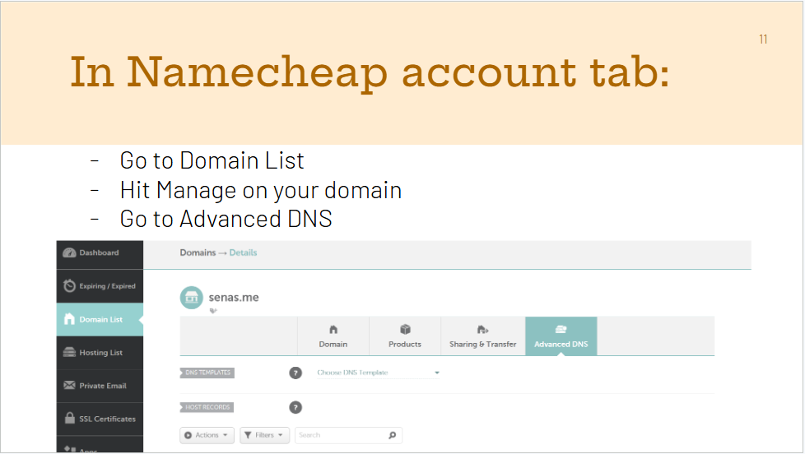
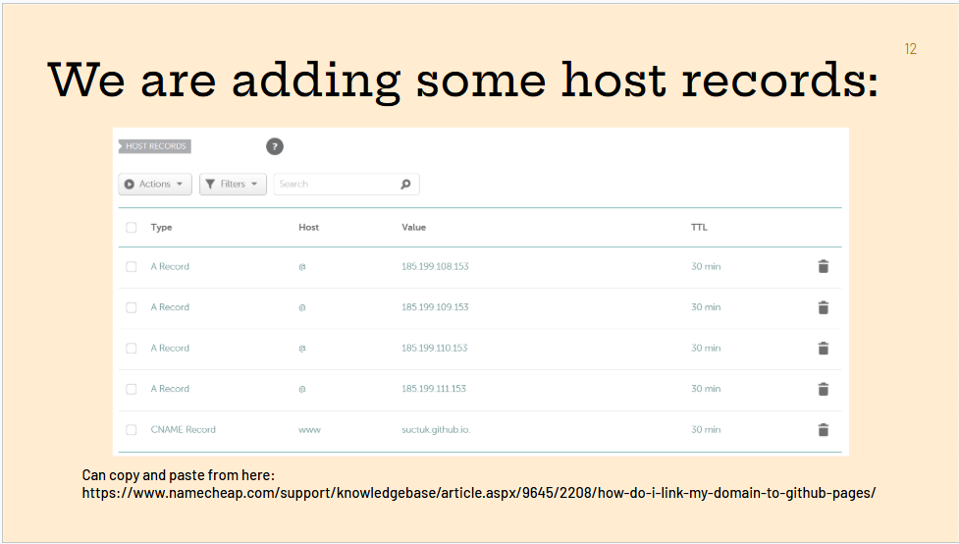
List of host records on: https://www.namecheap.com/support/knowledgebase/article.aspx/9645/2208/how-do-i-link-my-domain-to-github-pages/

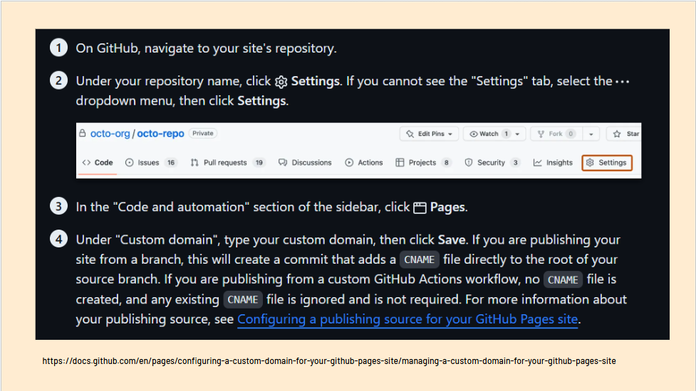
https://docs.github.com/en/pages/configuring-a-custom-domain-for-your-github-pages-site/managing-a-custom-domain-for-your-github-pages-site

Enforcing HTTPS
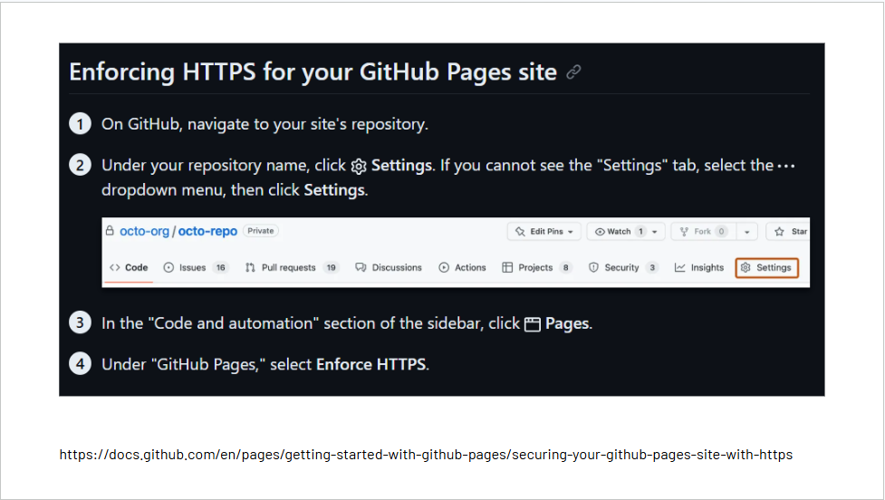
https://docs.github.com/en/pages/getting-started-with-github-pages/securing-your-github-pages-site-with-https

3/23 - Meeting Notes
We are living in an era of profound disorientation:
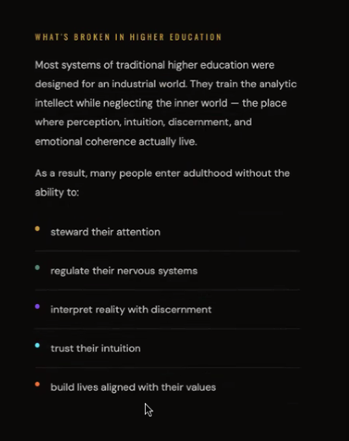
We like this color, and we like it matches
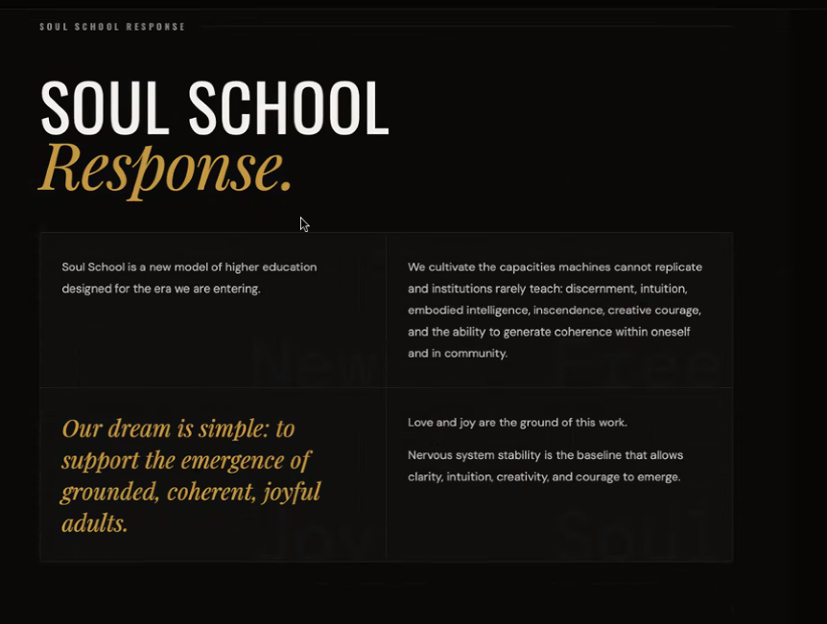
We like that soul school response is big, and our dream is simple is big

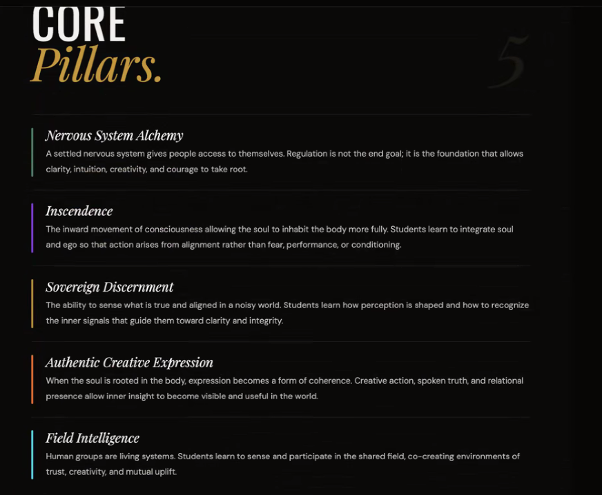
We like the brief synopsis of each of the pillars. Colors are consistent.
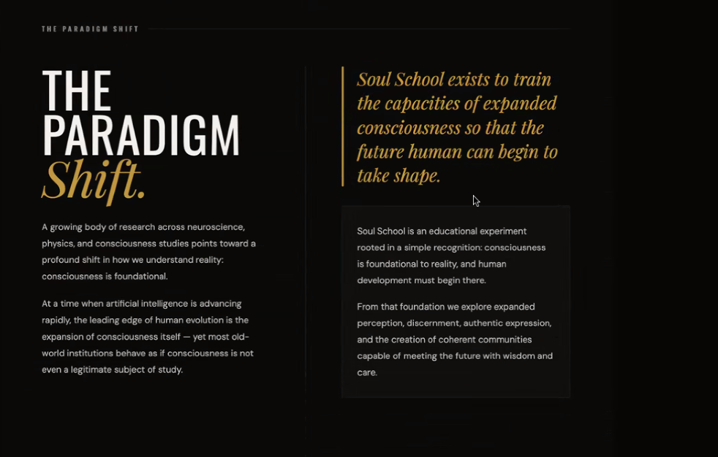
We like that the Soul School Exists to train line is big.

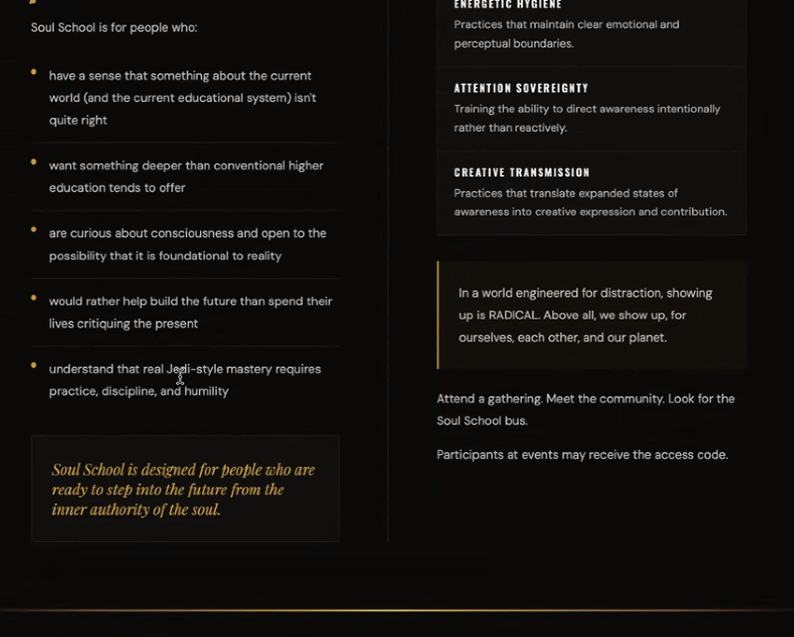
Soul School is designed for people who are ready. Keep that big and distinct.
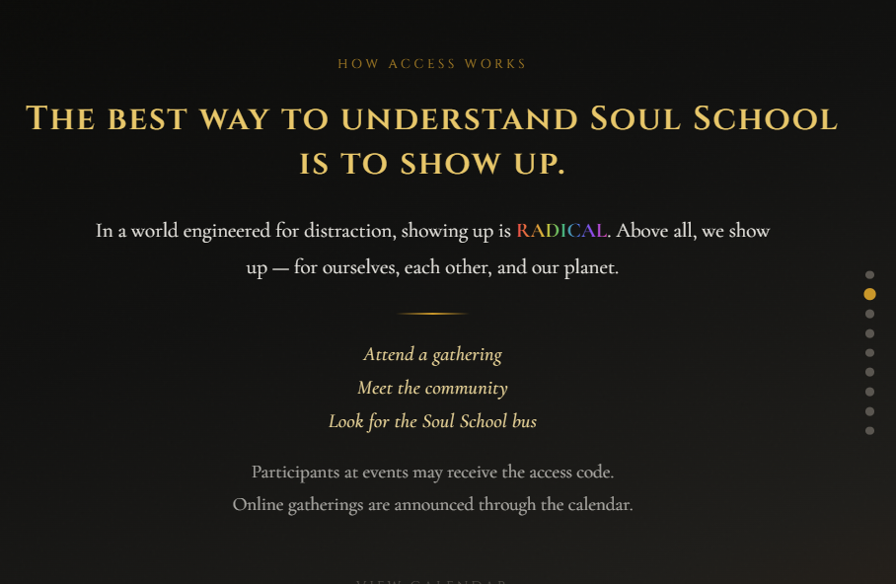
We like this page.

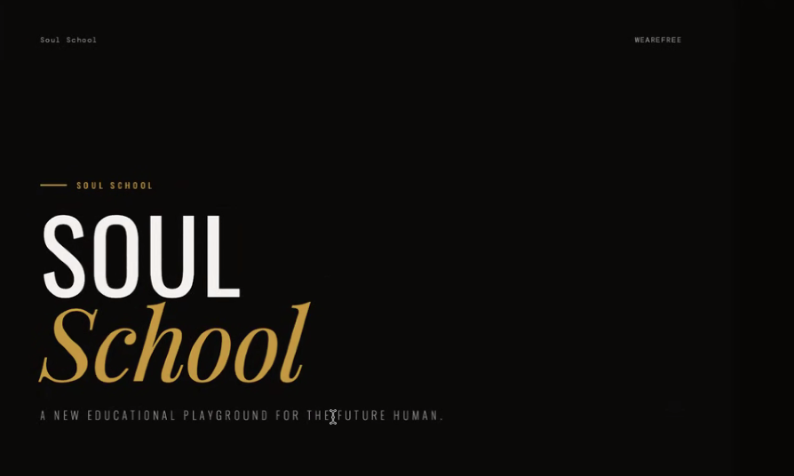
We like the spacing of the font of a new educational playground for the future human. We like wearefree in the corner.

Everything that is under soul school can be found on the internet via other systems. The password is a choice. People choose to see the information.
WEAREFREE. Anyone can have it, if they figure it out. Wearefree is an illusion

Member login we do care about
- Post excerpts from class.
- We want privacy here.

Soul School header provided.
The transmission of love and joy and the liberation of all beings.
That is the image we will use. We are going to color reverse.
- Image will be white text with a transparent background.

Annie will get headshots.

We will look in the next few days to figure out what headers we want to be as hand written.

Very biggest headers: We are soul school
- Will be written.

Make this Annie’s

What we like in the original:
Whats broken and soul school response paired in columns. Easy and clear to see what the issue is, with a solution.

So combine the what’s broken page with the response page. Make them columns like the original.

Home page: mess with
Handwritten
button
Button
Button
Calendar

When API is connected:
Just show what upcoming events are on the calendar. Not the full calendar look.

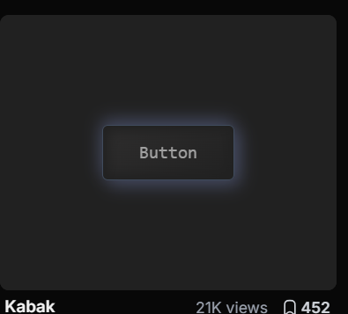
Pill shape with gold glow.
https://uiverse.io/buttons?page=0

We will set up domain next meeting.

Action Items:
Trace out banner
Write out optional things for What is soul school
Headshots
Write out:
- We Are Soul School
- What is
- People behind
Send Sena the template zine.
Set up Google Workspace

Senas:
- Draft Calendar items to see what they could look like on the home page.
- Figure out best way to secure API keys.

We want people to be able to contact us about registering.

If people want to start sharing, they need the time that proves they are vetted and ready because of the nature of the work.

Schedule 30 minute initiation conversation.
- Put it behind WEAREFREE
- Contact that route to email. - Sena will look into if this can write to google calendar and send notifications back to Soul School Email.

Sena will use google cloud console on personal.

